My Tomorrow Change Makers

Social Posts and School e-bulletins

Key Links:
Full length promo video: Change Makers teaches students how to stay safe and helps schools tackle the root causes of violence (youtube.com)
Socials promo video (portrait and widescreen to save to your PC): Updated Versions - Google Drive
My Tomorrow Webpage: My Tomorrow - West Midlands Violence Reduction Partnership (westmidlands-vrp.org)
Theme | Key Messages for Social – Keeps within X word count | Resource or artwork
Spreading the word | Post 1  The Change Makers Programme will be coming to [INSERT SCHOOL NAME] next term.  The curriculum will help students navigate real life challenges and call out harmful attitudes and behaviours around youth violence, VAWG and bullying.  It’s part of the youth-led #MyTomorrow campaign  Post 2  Schools across the West Midlands [or name of your borough] will soon start teaching the Change Makers curriculum.  These new lessons are designed to help students develop resilience, resolve conflict and stay safe #MyTomorrow  Post 3  A new educational programme designed to help schools tackle the root causes of youth violence and promote personal safety is rolling out across the West Midlands.  The Change Makers sessions have been co-designed with young people to make sure the scenarios discussed are relevant to their lives #MyTomorrow | 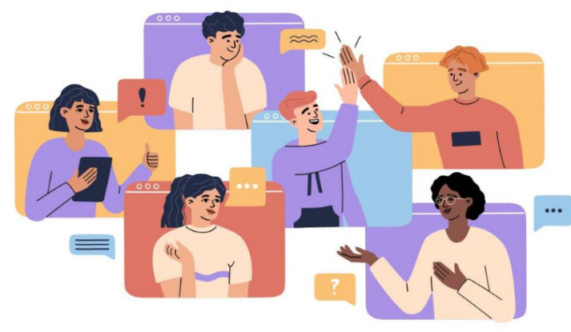  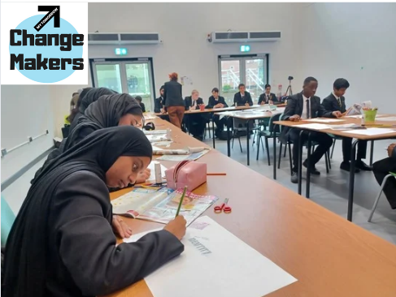  *Right click – ‘save as picture’ to your PC
Explaining the background | Thread 1  The #MyTomorrow campaign is about improving the life chances of young people across the West Midlands.  Schools play a vital role & can now deliver a fully-funded educational programme from @WestMidsVRP to help students stay safe, develop resilience and resolve conflict (1/3)  Thread 2  Change Makers has been co-designed by young people who have handpicked the themes for each session:  ✔️Identity  ✔️Safety  ✔️Relationships  ✔️Community  ✔️My Voice & Influence  ✔️My Tomorrow (2/3)  Thread 3:  Head to youtube to watch a lesson here - https://bit.ly/40iQcq7  And request training for your school staff by emailing - vrp@westmidlands.police.uk  Training can be delivered online or in person, after which your school will receive the online resource pack (3/3)  *Or one continuous post on Instagram/ Facebook – deleting ‘(1/3) (2/3) (3/3)’ | 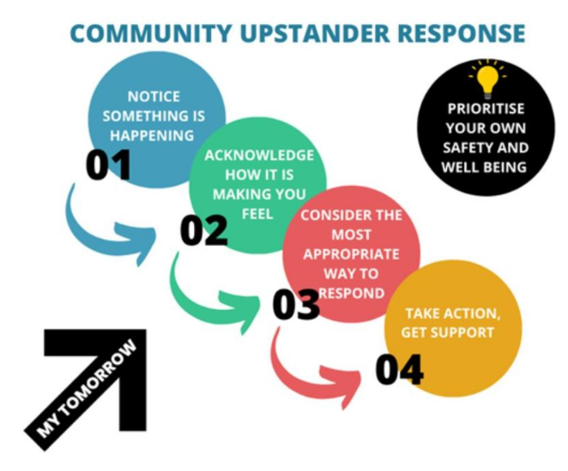  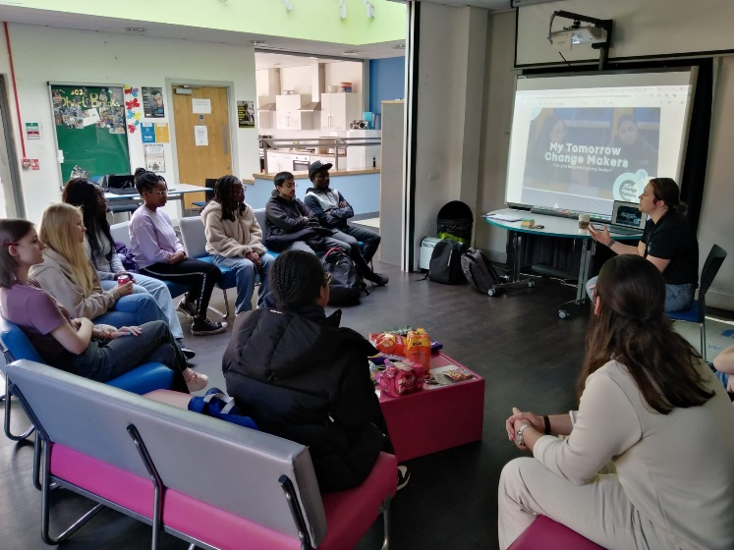  *Right click – ‘save as picture’ to your PC
Promoting your school | Post 1:  We are so excited to start the Change Makers programme with our Year 9 pupils today – with conversations around identity and belonging #MyTomorrow  The six sessions teach young people how to be upstanders – promoting personal safety and conflict resolution.  Post 2:  Our Year 10 pupils have been learning about staying safe on social media as part of the #MyTomorrow Change Makers Programme.  Post 3  So much enthusiasm for our session on community with our Year 7 pupils who were talking about safe spaces and contributing some fantastic ideas, as part of our new Change Makers programme | 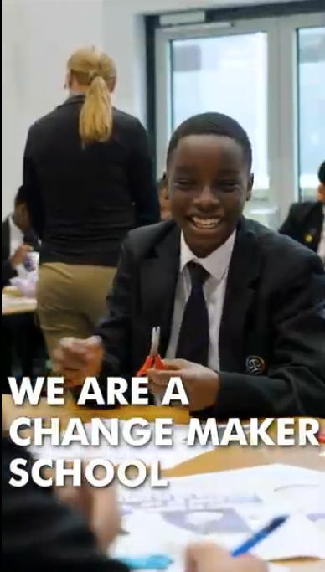  Socials promo video click here – Updated Versions - Google Drive  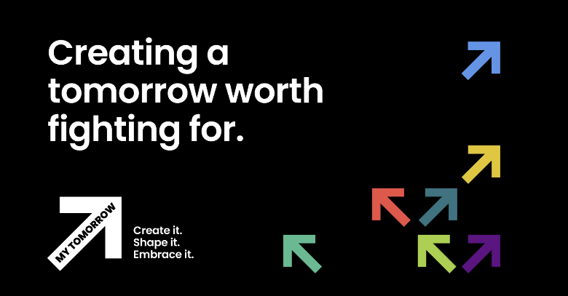  - School’s own pictures, graphics and videos  *Right click – ‘save as picture’ to your PC

Wording for school e-bulletins/ newsletters (two versions):
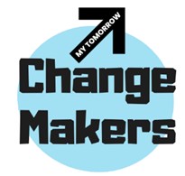
Violence Reduction Partnership - My Tomorrow Change Makers

An exciting, new programme in schools will help pupils develop resilience, resolve conflict and stay safe.
Students in Year 6 and above will benefit from the Change Makers sessions, which have been co-designed by young people as part of the youth-led My Tomorrow campaign.
The programme teaches young people how to be upstanders. It is fully-funded by the Violence Reduction Partnership (VRP), which will deliver the training to school staff.
To arrange your training session email vrp@westmidlands.police.uk. Training lasts approximately two hours. It’s delivered as a train the trainer model, which can be to small groups or whole school staff; online or in person. Your school will then receive the online resource pack which has everything you need to get started.
To see a session in action, take a look at this video from George Salter Academy - (1) The Change Makers Programme shows young people how to be upstanders - YouTube
For more information about the campaign and to download more free resources, including the My Tomorrow Activity Pack, please visit My Tomorrow - West Midlands Violence Reduction Partnership (westmidlands-vrp.org)
ENDS
Anti-violence campaign normalises taboo subjects, pupils say
A campaign in schools, which encourages young people to talk openly about consent, knife crime, bullying and gender stereotypes is helping to “normalise” previously taboo conversations, students have said.
The lessons in the Change Makers Programme have been co-designed by young people to ensure the topics discussed are relevant to their lives.
It has been funded by the West Midlands Violence Reduction Partnership (VRP) which is working directly with schools to empower youth voice as part of the My Tomorrow campaign.
To arrange your training session email vrp@westmidlands.police.uk. Training lasts approximately two hours. It’s delivered as a train the trainer model, which can be to small groups or whole school staff; online or in person. Your school will then receive the online resource pack which has everything you need to get started.
To see a session in action, take a look at this video from George Salter Academy - (1) The Change Makers Programme shows young people how to be upstanders - YouTube
For more information about the campaign and to download more free resources, including the My Tomorrow Activity Pack, please visit My Tomorrow - West Midlands Violence Reduction Partnership (westmidlands-vrp.org)

ENDS
………………………………………………………………………………………………………………………………………………………………………………………
For further comms support or bespoke messaging, articles or videos; please contact VRP partnership communications officer laura.chiverton@westmidlands.police.uk

